# INTRODUCTION

## Overview

#### The primary objective of the project to understand customers spending patterns performance and it tends to across various , By conducting a comprehensive analysis, business can option the marketing strategies, improve product offering and enhance customer engagement to drive revenue growth.

## Purpose

#### Whole sailing and distributing is the sale of goods to retails industrial, commercial institutional are other professional businessman to other wholesalers under retailers subordinator service.

#### Wholesale is here buying good in bulk quantity, usually directly from the manufacture are source, at a discount rate. The retailer then sells the goods to the end consumer at the high price making a profit.

# PROBLEM DEFINITION & DESIGN THINKING

## Empathy Map

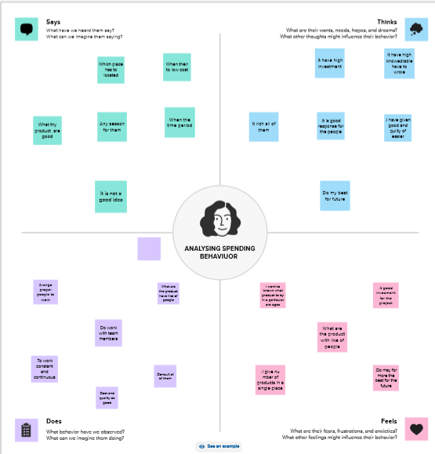

# Ideation & Brainstorming Map Screenshot

# C:\Users\arjun\Pictures\Screenshots\Screenshot (9).png

# RESULT

## C:\Users\arjun\Pictures\Screenshots\Screenshot (14).png

# ADVANTAGES & DISADVANTAGES

#### 1. Easier it use under adoption

#### 2. Employee availability and connectivity

#### 3. Employee productivity

#### 4. Work satisfaction

# Disadvantage

#### 1. Loss of process control

#### 2. Security issues

#### 3. Support complexity

#### 4 Stress and work overloaded

# APPLICATIONS

#### 1. The Rapid digital transformation increasing adoption of advanced Technologies.

#### 2. Agreements, collaboration and partnerships are likely to the key growth strategies.

# CONCLUSION

#### Purpose and business growth through enhanced interactions and personalized experience accelerates.

# FUTURE SCOPE

#### 1. Asia pacific market has projected to grow from USD 2.8 billion in 2023 to USD 6.0 billion by 2028.

#### 2. Emphasis on patient centric care and improved Healthcare outcomes provides the customer experience of them.